

**Independent University Bangladesh**

Department of Electrical and Electronics Engineering

**Project on Digital Filter Design**

Name: Hemal Sharma

Id: 2221855

Cours Code: EEE 321

Couse: Digital Signal Processing Lab

Semester: Spring 2024

Date: 25/04/2024

**Objective:**

Design and apply digital filters to noisy electrocardiogram (ECG) signal, with the aim of removing unwanted noise.

**Introduction:**

Biomedical signals, such as electrocardiograms (ECGs), are crucial for diagnosing and monitoring various heart conditions. However, these signals are often corrupted by noise during acquisition. This project aims to design and apply digital filters in MATLAB to remove noise from a raw ECG signal, improving its quality for analysis. Digital filters, such as Finite Impulse Response (FIR) and Infinite Impulse Response (IIR) filters, offer powerful tools for removing noise from biomedical signals while preserving essential diagnostic information.

**FIR Filters:**

FIR filters produce a system's finite impulse response, meaning their impulse response is of finite length. FIR filters exhibit a linear phase response, and their system function consists solely of b coefficients. Due to the absence of poles, the system remains inherently stable. Designing higher-order FIR filters may be necessary, and they operate as open-loop systems. FIR filters are versatile, applicable to both analog and digital signal filtering, albeit with higher computational complexity compared to some alternatives.

**IIR Filters:**

IIR filters stand for Infinite Impulse Response, its phase response is non-linear as these filters have an internal feedback system, meaning that the system has both bm coefficients and ak coefficient is present. IIR filters are used in systems that produce infinite outputs, so therefore, IIR filters are represented as closed loop systems since they are utilized in systems that generate endless outputs. Despite having a reduced computational cost, the system may become unstable if the poles are located on the right.

In the context of filtering noisy biomedical signals like ECG, the choice between IIR and FIR filters hinges on factors such as computational complexity, filter characteristics, and stability requirements. IIR filters typically offer steeper roll-off in frequency response with fewer parameters, making them computationally efficient but potentially prone to phase distortion and instability. FIR filters, on the other hand, can achieve linear phase response and stability at the expense of higher computational demands due to more tap weights. Ultimately, the selection between IIR and FIR filters depends on balancing these trade-offs to best suit the specific needs of the application, such as preserving signal timing and minimizing noise while considering available computational resources.

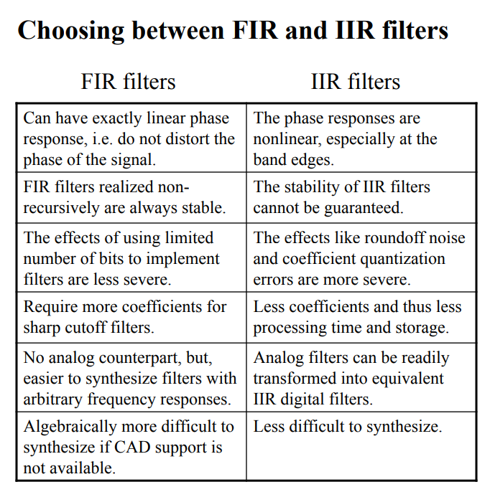

Figure 1 Comparison between FIR & IIR Filters

In this project, I will be using IIR Filter as it requires lower order or less computational complexity and no separate window design.

**Methodology:**

There are two approaches of basic IIR filter design technique:

For this approach, I will be using the latter method. It allows for the design of an analog low-pass filter, followed by filter transformation from the s-domain to the z-domain before applying frequency band transformations, offering several benefits. Firstly, by directly transforming the analog filter prototype into the digital domain, it eliminates the need for intermediate analog-to-digital conversion steps, simplifying the overall design process. Secondly, this approach provides greater flexibility in manipulating the filter characteristics in the digital domain, allowing for precise control over parameters such as cutoff frequency, passband ripple, and stopband attenuation.

**Filter Specifications**:

When designing filter relative specifications are required, where Rp is the pass band ripple factor and As is the stop band attenuation in dB.

Figure 2 Relative Specification

Figure 1 Absolution Specification

**Filter Type:**

There are three widely used prototype analog filters:

1. Butterworth filters
2. Chebyshev filters

* Chebyshev type-I
* Chebychev type-II

1. Elliptic filters.

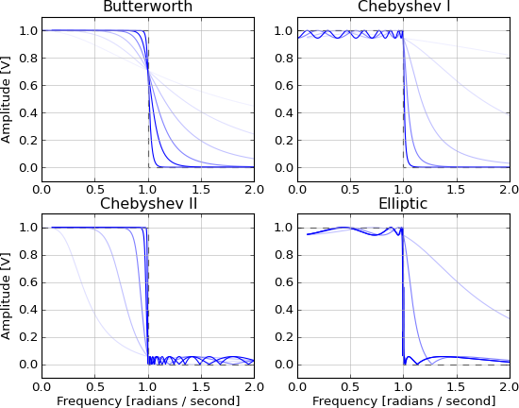

Figure 2 Frequency response of IIR Filters

**Butterworth Filter:** Characterized by a maximally flat passband with no ripple, providing a smooth frequency response ideal for applications requiring uniform attenuation across the passband.

**Chebyshev Type I Filter:** Achieves steeper roll-off in the stopband compared to Butterworth filters but introduces ripple in the passband, suitable for applications where sharp transition between passband and stopband is important.

**Chebyshev Type II Filter:** Provides sharp roll-off in the stopband with ripple in the stopband instead of the passband, beneficial in applications prioritizing minimal distortion in the passband.

**Elliptic Filter:** Offers the steepest roll-off among IIR filters for a given order by allowing ripple in both passband and stopband, advantageous in applications requiring very sharp transition bands and high stopband attenuation.

|  |  |  |  |
| --- | --- | --- | --- |
| Filter Type | Pass-band | Stop-band | Roll-off |
| Butterworth | Flat, No Ripple | Gradual | Moderate |
| Chebyshev Type I | Ripple | Sharp | Steep |
| Chebyshev Type II | Flat | Ripple | Steep |
| Elliptic | Ripple | Ripple | Steepest |

For this project, I will be using the Butterworth filter as it provides a balance among various tradeoffs. With a flat passband characterized by minimal ripple, the Butterworth filter ensures that our desired ECG component, which typically resides in the lower frequency range, can be efficiently preserved. This makes it an optimal selection for our application. Additionally, its inherent design offers a smooth transition from the passband to the stopband, contributing to the effective suppression of unwanted higher frequency noise or interference.

**The Butterworth Low Pass Filter:**

A Butterworth low pass filter is usually represented by its magnitude-square response shown below, where Ω𝑐 is as the order is increased.

For the filter response in s-domain, the poles of the filter needs to be determined using either of the equations (depending on the filter order, N).

**Simulation:**

At first, I have plotted the time domain and frequency domain spectrum of the provided Raw and Clean ECG Signal. From the frequency domain plot of Raw ECG signal, one can observe there is a sharp monotone peak at 50 Hz.



Figure 3 Time Domain Plot of Raw and Clean ECG Signal



Figure 4 Frequency Domain Plot of Raw and Clean ECG Signal

To suppress the 50Hz noise in the Raw ECG signal, I utilized a Butterworth band-stop filter with cutoff frequencies set at 49 Hz and 51 Hz, and the filter order was chosen to be 3. Subsequently, I designed a Butterworth Low Pass Filter as the desired ECG signal's bandwidth lies below 100Hz. After analyzing the frequency plot of the clean ECG signal, I determined a cutoff frequency of 60Hz, as the intensity significantly decreases beyond this point. The filter order was also set to 3, based on an evaluation of performance parameters such as correlation coefficient, root mean square error, magnitude squared coherence, and SNR. Since altering the filter order didn't result in significant changes in these metrics, the priority was to choose a lower order to reduce complexity.

**Filter Order vs Performance Parameters:**



Figure 5 Time domain Plot



Figure 6 Power Spectral Density Plot



Figure 7 Magnitude & Phase response.

**Matlab Code:**

close all;

clear all;

%% Load ECG data

load('ECG_Clean.mat')

load('ECG_Raw.mat')

Fs = 300;

dt = 1/Fs;

t = (0:dt:(length(ECG_Raw)*dt)-dt)';

%% Filter

% Define the notch filter frequencies

fc1 = 49; % Lower notch frequency

fc2 = 51; % Upper notch frequency

% Design Butterworth notch filter

[b_notch, a_notch] = butter(3, [fc1 fc2]/(Fs/2), 'stop');

% Apply Butterworth notch filter to remove 50 Hz noise

ECG_Raw_notch_removed = filtfilt(b_notch, a_notch, ECG_Raw);

% Design Butterworth low-pass filter

fc_lp = 60; % Cutoff frequency for low-pass filter

[b_lp, a_lp] = butter(3, fc_lp/(Fs/2), 'low');

% Apply Butterworth low-pass filter

filtered = filtfilt(b_lp, a_lp, ECG_Raw_notch_removed);

%% PSD

PSD_r= pwelch(ECG_Raw);

PSD_c= pwelch(ECG_Clean);

PSD= pwelch(filtered);

%% Plots

% Time Doamin Plot

figure(1)

subplot(3,1,1)

plot(t,ECG_Raw)

xlabel('Time(Sec)');

ylabel('Amplitude');

title('Noisy ECG Signal');

subplot(3,1,2)

plot(t,ECG_Clean)

xlabel('Time(Sec)');

ylabel('Amplitude');

title('Clean ECG Signal');

subplot(3,1,3)

plot(t,filtered);

xlabel('Time(Sec)');

ylabel('Amplitude');

title('Filtered ECG Signal');

% Low pass filter response in magnitude and phase

figure(2)

freqz(b_lp,a_lp)

% plot PSD

figure (3);

subplot(3,1,1); plot(PSD_r); title('PSD of Noisy ECG');

subplot(3,1,2); plot(PSD_c); title('PSD of clean ECG');

subplot(3,1,3); plot(PSD); title('PSD of filtered ECG');

%% Perfomance calculation

msc= mean(mscohere(filtered,ECG_Clean));

corr= det(corrcoef(filtered,ECG_Clean));

before= rmse(ECG_Clean,ECG_Raw);

after= rmse(ECG_Clean,filtered);

r = snr(ECG_Raw,filtered);

**Discussion:**  
Upon analyzing the raw ECG signal, a notable high-pitch noise at 50Hz was observed. To suppress the noise, a Butterworth band-stop filter was applied. Subsequently, I designed a Butterworth Low Pass Filter to address the high-frequency noise, considering that the desired ECG signal's bandwidth lies below 100Hz as mentioned. After analyzing the frequency plot of the clean ECG signal, a cutoff frequency of 60Hz was determined, as the intensity significantly decreases beyond this point. The filter order was also set to 3, based on an evaluation of performance parameters such as correlation coefficient, root mean square error, magnitude squared coherence, and SNR. Since altering the filter order didn't result in significant changes in these metrics, the priority was to choose a lower order to reduce complexity.

**Conclusion:**

In conclusion, we were somewhat successful to filter the noise from the raw ECG signal. The PSD and the time domain plot of the filtered signal resembled to the clean ECG signal. We have also compared various performance parameter such as correlation coefficients, root mean square error (RMSE), magnitude squared coherence and Signal to noise ratio (SNR). Our correlation coefficient of 0.75 indicates a positive correlation, suggesting that the filtered signal closely resembles the clean ECG signal, while the low RMSE value indicates a smaller discrepancy between the signals, suggesting that the filtering process has effectively preserved the characteristics of the original signal.

Top of Form

**References:**

[1] John G. Proakis, Dimitris G. Manolakis, and Dimitris Manolakis, Digital Signal Processing, Prentice Hall, 2006

[2] Vinay K. Ingle, John G Proakis, Digital Signal Processing Using MATLAB, Prentice Hall

[3] <https://en.wikipedia.org/wiki/Digital_filter>

[4] https://en.wikipedia.org/wiki/Butterworth_filter

[5] <https://www.mathworks.com/help/signal/ref/butter.html>

[6] <https://www.mathworks.com/help/signal/ug/power-spectral-density-estimates-using-fft.html>

[7] <https://circuitglobe.com/difference-between-fir-filter-and-iir-filter.html>

|  |  |  |
| --- | --- | --- |
| **Attributes of Complex Engineering Problems** | | **Addressing the complex engineering problems in the project** |
| WP1 | Depth of knowledge required (WK3-WK5, WK8) | Comprehending the working principle of a Digital Filter, FIR Filter and IIR Filter |
| WP2 | Range of conflicting requirements | It is conflicting to choose in between FIR and IIR Filter since both has its tradeoffs. |
| WP3 | Depth of analysis required | Determine the order and cutoff frequencies of the digital filters through analysis of the given problem and the corrupted ECG Signal |
| WP4 | Familiarity of issues | MATLAB functions such as pwelch,corrcoef, snr, mscohere |